Visualization of background radiation in augmented reality

Ilya Yushin1*, Vladislav Romanenko1, Pavel Pugachev1, Pavel Kiryukhin1, Aleksander Shcherbakov1, Dmitriy Khomyakov1 and Georgy Tikhomirov1

1 National Research Nuclear University MEPhI (Moscow Engineering Physics Institute) 115409, Russian Federation, Moscow, Kashirskoe shosse, 31  
yushin7676@gmail.com

**Abstract**. Minimization of the dose load on personnel of nuclear facilities is an important task. This work focuses on the possibilities of reducing the accumulated dose rate using augmented reality technology. The concept of a system for visualizing the distribution of the radiation background in a workroom located in the educational laboratory of the Department of Theoretical and Experimental Physics of Nuclear Reactors at National Research Nuclear University MEPhI is proposed. The workroom contains subcritical experimental facilities with sources of ionizing radiation. The system allows avoiding places of increased radiation, thereby minimizing the dose load. The concept is implemented in the form of an Android application made on Unreal Engine 4. The application creates a multi-colored fog, the color of which at each point depends on the dose rate of gamma radiation.

**Keywords:** Augmented reality, Unreal Engine, dose rate, visualization.

1. Introduction

It is known that the high levels of radiation dose can harm a person, which is essential for workers in the nuclear industry who handle nuclear materials or maintain sites with intense neutron or gamma radiation. Therefore, the management ensures that the dose absorbed by the personnel does not exceed the standards [1] and takes organizational, technical [2 - 4], and medical [5] measures to protect against radiation. The risk of radiation sickness also decreases with the experience of the employees themselves; therefore, they undergo regular training.

The development of computer technology has provided new opportunities in the management and training of workers in the nuclear industry and the training of students. Recently, tremendous attention has been paid to augmented (AR) and virtual reality (VR) systems in the nuclear field. For example, a training system for consolidating the basic principles of nuclear safety and measurements, made in a game in which the user places barrels with radioactive waste and observes the distribution of the radiation background in space [6]. The creators note the effectiveness of the application for basic nuclear safety training. The digital twin of the JET tokamak - VORTEX [7] made it possible to reduce the radiation dose received by the personnel during the tokamak shutdown procedure by 40%. A simulation model of water infiltration for radioactive waste [8] makes it possible to observe the penetration of radioactive waste outside the warehouse, forming an understanding of these processes. The radiological exposure model using a system of exercises based on virtual reality [9] allows the user to select the optimal route to follow during an emergency empirically. The optimal route is the one with the shortest travel time and the lowest dose. Using neural networks, interpolating the radiation dose rate at nuclear power plants is also proposed [10] for training. VR is used to ensure the physical safety of nuclear facilities [11], to simulate a virtual environment for assessing doses at nuclear power plants [12], for education, training, and increasing human productivity in the nuclear industry [13]. An application has been developed for training NPP operators, in which a database has been created containing dose rates at a transfer station [14] and a model of a nuclear power plant for operational monitoring of the radioactive environment and assessment of doses for personnel [15].

The virtual reality laboratory of the National Research Nuclear University MEPhI [16] is engaged in creating virtual analogs and digital twins of physical systems in the nuclear industry. This work is a continuation of work on creating virtual analogs of uranium-graphite and uranium-water subcritical assemblies [17] and Godiva's critical facility in VR [18]. Subcritical experimental assemblies provide unique data that can be used to refine concepts for connecting VR/AR technologies and physics simulations. This work considers the creation of an AR application that allows visualizing the background radiation in a workroom based on experimental measurements.

1. Methodology

The possibility of visualizing the radiation background in a workroom with subcritical facilities requires having data on radiation with the coordinates of the measurement points. By this, the technique for constructing a three-dimensional distribution of gamma radiation consisted of the following stages:

* building a three-dimensional model of the workroom;
* measuring the background radiation;
* correlating the measurement points with the coordinate system;
* three-dimensional interpolation of the gamma radiation power.
  1. 3D-model of the working room and measurement of the background radiation

ZED 2 stereo camera was used to obtain a 3D model of a room with subcritical stands. ZED 2 provides the ability to create a point cloud or a polygonal model of the environment both in real-time and by processing previously recorded videos. The resulting point cloud was subsequently processed in the MeshLab program. A three-dimensional model of the room and measurement points of the background radiation in the room are shown in Fig. 1. Measurements of the background radiation were carried out using an MKS-AT117M radiometer and a BDKG-04 detection unit at the same height. Finally, a regular two-dimensional grid was built based on the measurement results, shown in Fig. 1.

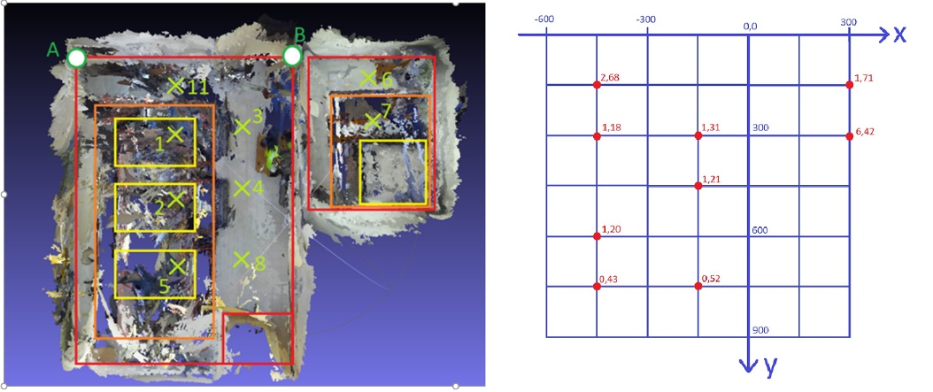

**Fig. 1.** Workroom model (left, top view of the point cloud) with superimposed points and a 2D partially filled regular grid (right).

The measurement results with the corresponding coordinates are shown in Table 1.

**Table 1.** The measurement results with the corresponding coordinates.

|  |  |  |
| --- | --- | --- |
| № | Dose rate of gamma radiation, μSv/hour | Coordinates, cm |
| 1 | 1,18 | -427:284 |
| 2 | 1,20 | -427:533 |
| 3 | 1,31 | -177:267 |
| 4 | 1,21 | -177:498 |
| 5 | 0,43 | -427:782 |
| 6 | 1,71 | 284:89 |
| 7 | 6,42 | 302:249 |
| 8 | 0,52 | -177:764 |
| 11 | 2,68 | -427:107 |

* 1. Generation of a three-dimensional radiation dose rate distribution

An unfilled 2D grid was transformed into a filled 3D grid to visualize the gamma power distribution. The 3D grid contains 7x7x7 points. In this case, the third vertical layer, corresponding to the elevation at which the background measurements were carried out, contains nine filled points. The calculation of the radiation power at the empty points is the following procedure:

1. The values ​​of the radiation power in the empty points are assumed to be zero.
2. Radiation dose rates in the empty points are calculated as the arithmetic mean of the values ​​in the neighboring nodes.
3. Step 2 is performed iteratively until the calculated values ​​converge with an accuracy of 0.01 μSv/h.

According to radiation dose rates, calculated at the nodes of a regular grid, in the AR application, the dose rate distribution is interpolated in space, and the space is colored for visualization.

1. Implementation of an AR application

The AR application is made in Unreal Engine 4. It was decided to visualize the radiation power distribution using ten concentric semi-transparent spheres with a common center tied to the phone's location. Coloring such spheres create the "fog" effect illustrated in Fig. 2. Coloring is done using the material in Unreal Engine 4, which contains three shaders. The first HLSL shader outputs the gamma value based on a 3D regular grid, and the others paint concentric spheres based on the results of the first shader. The color depending on the coordinate, is calculated by the trilinear interpolation method. The fog opacity is changed with the upper slider.

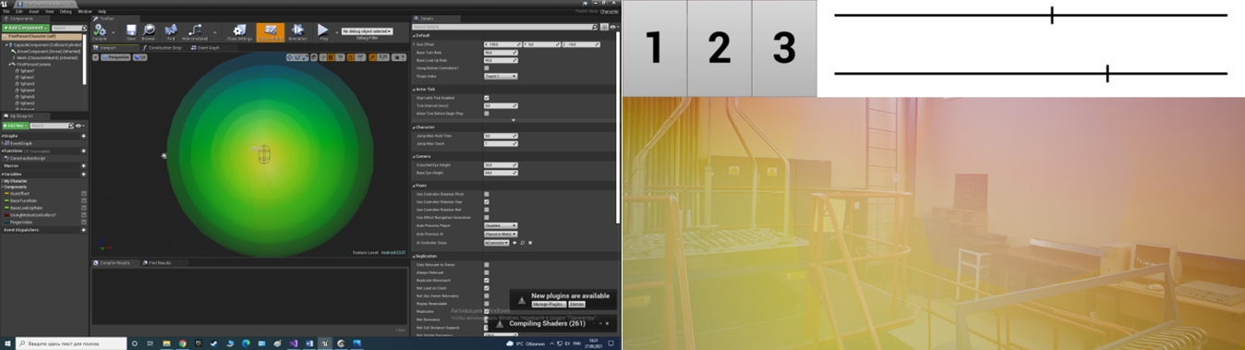

**Fig. 2.** Fog implementation in Unreal Engine (left) and in application (right)

For convenience, a widget with buttons and sliders has been added to the application. Buttons 1-3 allow one to select a color scheme for coloring. The upper slider adjusts the transparency, and the lower one changes the dependence of the transparency on the dose rate of gamma radiation. The screenshot shows a burst of radioactivity at point 11 (red). At the moment, the application needs to be launched at a specific point in the workroom for the correct display of the radiation dose rate distribution. The standard ARcore tracker to track the phone's position in space was chosen, using the phone's camera, gyroscope and accelerometer.

The application was tested on a Sony XPERIA XZ1 phone (model G8342) with Android 9. The test was carried out in the workroom with subcritical stands of the National Research Nuclear University MEPhI. The correspondence of the fog color with the dosimeter readings was visually assessed (a red spot is observed at points 7 and 11).

1. Conclusion

This paper discusses the possibility of using AR technology in the nuclear industry to reduce the impact of radiation on the personnel of nuclear power plants and other enterprises. The concept of visualization of the distribution of gamma radiation power, implemented in an Android augmented reality application, is proposed. The application allows one to notice and avoid intense bursts of background radiation; however, using the visualization in the fog does not work well at long distances. The disadvantage of the application is the instability in determining the coordinates of external objects, so it is planned to improve tracking in the future. In this work, only static visualization of the background was considered. A dynamic change in the radiation environment can be realized if there is sufficient equipment for detecting radiation in the room. It should be noted that it is inconvenient to use a telephone to monitor the radiation situation in a natural working environment. Nevertheless, with the advent of augmented reality glasses, this technology may be more convenient and show an actual reduction in the dose load on the personnel of nuclear facilities.

References

1. Onishchenko G.: Normy radiatsionnoy bezopasnosti (NRB-99/2009): Sanitarno-epidemiologicheskiye pravila i normativy. Federal'nyy tsentr gigiyeny i epide-miologii Rospotrebnadzora, Moskva (2009).
2. Senyuk O., Krasnov V., Danilov V.: Radiatsionnaya zashchita personala dey-stvuyushchikh aes i ob"yekta «ukrytiye», sushchestvuyushchiye problemy, strategiya i taktika ikh resheniya segodnya. s. 9 – 24. Problemi bezpeki atomnikh yelektrostantsíy í chorno-bilya vip. 3 CH. 1 (2005).
3. Dollezhal' N.: Osnovy radiatsionnoy bezopasnosti atomnykh elektrostantsiy. Energoizdat, Moskva (1982).
4. Atoyan, V et all: Optimizatsiya radiatsionnoy zashchity pri kontrole oblucheniya per-sonala. MAGATE, Vena (2003).
5. Gorovoy L. et all.: Radiosorbtsionnyye svoystva khitin-melaninovykh kompleksov i perspektivy ikh ispol'zovaniya v radiatsionnoy zashchite. Problemi bezpeki atomnikh yelektrostantsíy í chornobilya vip. 3 CH. 1 (2005).
6. [Hagita](https://www.sciencedirect.com/science/article/pii/S0149197019302367#!) K., [Kodama](https://www.sciencedirect.com/science/article/pii/S0149197019302367#!) Y., [Takada](https://www.sciencedirect.com/science/article/pii/S0149197019302367#!) M.: Simplified virtual reality training system for radiation shielding and measurement in nuclear engineering. doi: [10.1016/j.pnucene.2019.103127](https://doi.org/10.1016/j.pnucene.2019.103127).

1. [Naish](https://www.sciencedirect.com/science/article/pii/S0920379617303496" \l "!) J., [Burns](https://www.sciencedirect.com/science/article/pii/S0920379617303496#!) A.: Minimising operator dose during JET shutdown using virtual reality. doi: [10.1016/j.fusengdes.2017.03.131](https://doi.org/10.1016/j.fusengdes.2017.03.131).

1. [Gabcan](https://www.sciencedirect.com/science/article/pii/S0306454919307753" \l "!) L., [Alves](https://www.sciencedirect.com/science/article/pii/S0306454919307753#!) A., [Frutuoso e Melo](https://www.sciencedirect.com/science/article/pii/S0306454919307753#!) P.: 3D simulation model of water infiltration for radioactive waste on a virtual reality Environment: An application to the Abadia de Goiás repository. doi: [10.1016/j.anucene.2019.107265](https://doi.org/10.1016/j.anucene.2019.107265).
2. [Lee](https://www.sciencedirect.com/science/article/pii/S1738573317306502#!) D., [Lee](https://www.sciencedirect.com/science/article/pii/S1738573317306502#!) B., [Park](https://www.sciencedirect.com/science/article/pii/S1738573317306502#!) Y, [Kim](https://www.sciencedirect.com/science/article/pii/S1738573317306502#!) D.: Application plan for radiological exposure model using virtual reality–based radiological exercise system. doi: [10.1016/j.net.2018.03.009](https://doi.org/10.1016/j.net.2018.03.009).

1. [A.Mól](https://www.sciencedirect.com/science/article/pii/S0306454910002859" \l "!) A. C., [N.A.Pereira](https://www.sciencedirect.com/science/article/pii/S0306454910002859#!) C. M., [G.Freitas](https://www.sciencedirect.com/science/article/pii/S0306454910002859#!) V. G., [F.Jorge](https://www.sciencedirect.com/science/article/pii/S0306454910002859#!) C. A.: Radiation dose rate map interpolation in nuclear plants using neural networks and virtual reality techniques. doi: [10.1016/j.anucene.2010.08.008](https://doi.org/10.1016/j.anucene.2010.08.008).
2. [Henrique da Silva](https://www.sciencedirect.com/science/article/abs/pii/S0149197014001851#!) M., [Cotelli do Espírito Santo](https://www.sciencedirect.com/science/article/abs/pii/S0149197014001851#!) A., [Rangel Marins](https://www.sciencedirect.com/science/article/abs/pii/S0149197014001851#!) E., [Paula Legey de Siqueira](https://www.sciencedirect.com/science/article/abs/pii/S0149197014001851#!) A., [Machado Mol](https://www.sciencedirect.com/science/article/abs/pii/S0149197014001851#!) D., [Carlos de Abreu Mol](https://www.sciencedirect.com/science/article/abs/pii/S0149197014001851#!) A.: Using virtual reality to support the physical security of nuclear facilities. doi: [10.1016/j.pnucene.2014.07.004](https://doi.org/10.1016/j.pnucene.2014.07.004).
3. [A.Mól](https://www.sciencedirect.com/science/article/pii/S0306454910002859#!) A. C., [F.Jorge](https://www.sciencedirect.com/science/article/pii/S0306454910002859#!) C. A., [M.Couto](https://www.sciencedirect.com/science/article/abs/pii/S0149197008000784#!) P., [C.Augusto](https://www.sciencedirect.com/science/article/abs/pii/S0149197008000784#!) S., [G.Cunha](https://www.sciencedirect.com/science/article/abs/pii/S0149197008000784#!) G., [Landau](https://www.sciencedirect.com/science/article/abs/pii/S0149197008000784#!) L.: Virtual environments simulation for dose assessment in nuclear plants. doi: [10.1016/j.pnucene.2008.04.003](https://doi.org/10.1016/j.pnucene.2008.04.003).
4. Xi C., Wu H., Joher A., Kirsch L., Luo C., Khasawneh M., Rizwan-uddin (2009). 3-D virtual reality for education, training and improved human performance in nuclear applications. In 6th American Nuclear Society International Topical Meeting on Nuclear Plant Instrumentation, Control, and Human-Machine Interface Technologies 2009 (pp. 2347-2356).
5. Ródenas J., Zara I., Burgos M., Felipe A., Sánchez-Mayoral M.: Development a virtual reality application for training nuclear power plant operators: setting up a database containing dose rates in the refueling plant. doi: [10.1093/rpd/nch043](https://doi.org/10.1093/rpd/nch043).

1. [A.Mól](https://www.sciencedirect.com/science/article/pii/S0306454909002746" \l "!) A. C., [C.Aghina](https://www.sciencedirect.com/science/article/pii/S0306454909002746#!) M. A., [F.Jorge](https://www.sciencedirect.com/science/article/pii/S0306454909002746#!) C. A., [F.Lapa](https://www.sciencedirect.com/science/article/pii/S0306454909002746#!) C. M., [M.Couto](https://www.sciencedirect.com/science/article/pii/S0306454909002746#!) P.: Nuclear plant’s virtual simulation for on-line radioactive environment monitoring and dose assessment for personnel. doi: [10.1016/j.anucene.2009.08.013](https://doi.org/10.1016/j.anucene.2009.08.013).
2. Virtual reality laboratory MEPhI homepage, <https://vr.mephi.ru/>, last accessed 2021/10/14
3. Kiryukhin P., Shcherbakov A., Romanenko V., Pugachev P., Khomyakov D., Tikhomirov G., Zadeba E. (2020). Development of a virtual analogue of uraniumgraphite subcritical assembly and visualization of the neutron flux distribution in virtual reality. Procedia Computer Science, 169(2019), 192–197. doi: [10.1016/j.procs.2020.02.135](https://doi.org/10.1016/j.procs.2020.02.135).
4. Dashanova, E., Zadeba, E., Kiryukhin, P., Pugachev, P., Romanenko, V., Tikhomirov, G., Khomyakov, D., Shcherbakov, A., & Yushin, I. (2020). Development of virtual analogues of nuclear facilities in virtual reality. Journal of 15 Physics: Conference Series, 1689(1). [doi: 10.1088/1742-6596/1689/1/012062](https://doi.org/10.1088/1742-6596/1689/1/012062).